Building for Tomorrow’s Leaders
PRIME
ARCADIS U.S., INC.
Barbara Serata
(213) 842-3839
barbara.serata@arcadis.com

CONTACT

IEM INTERGRATED ENGINEERING MANAGEMENT
Contact: Behjat Zanjani
Telephone: 310-221-0749
E-mail: bzanjani@iemcm.com

02EPCM
Contact: Omoné O. Livingston
Telephone: 213-267-8284
E-mail: omoneo@o2epcm.com

AIM CONSULTING SERVICES
Contact: Gabriel Perez
Telephone: 323- 271-4602
E-mail: gperez@aimcsworld.com

BEEZLEY MANAGEMENT, A CBRE Company
Contact: Jonathan Levy
Telephone: 818-585-4829
E-mail: jlevy@beezleymanagement.com

BIGGS CARDOSA ASSOCIATES, INC.
Contact: Michael Thomas
Telephone: 714-550-4665
E-mail: mthomas@biggscardosa.com

BORJ CONSTRUCTION MANAGEMENT, INC.
Contact: Nader Farnoush
Telephone: 323-864-3020
E-mail: nader.farnoush@borjcm.com

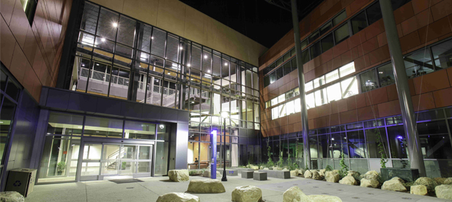

CITADEL CPM, INC.
Contact: Fadi Rassam
Telephone: 626-796-7926
E-mail: frassam@citadelcpm.com

DACM PROJECT MANAGEMENT, INC
Contact: Deborah M. Dugan
Telephone: 818-752-2970
E-mail: dduganceo@dacmpm.com

ECM GROUP
Contact: Hector A. Castillo
Telephone: 213-353-9438

NAGYIVANY INSPECTION CONSULTANTS, INC.
Contact: Leah Nagyivanyi
Telephone: 661-904-0368
E-mail: leah@NIC-Inc.org

PARTHENON CORPORATION
Contact: Ernesto Trias
Telephone: 323-336-2221
E-mail: operations@parthenoncorp.com

PLANCORP
Contact: Joyce R. Henderson
Telephone: 323-222-1575
E-mail: plancorpLA@aol.com

E-mail: hector@ecmcorporation.com

GAFCON, INC.
Contact: Robin Duveen
Telephone: 858-875-0010
E-mail: rduveen@gafcon.com

KANIRA CONSULTING INC.
Contact: Raju Kaval
Telephone: 213-840-0896
E-mail: kanira@outlook.com

LENAX CONSTRUCTION SERVICE
Contact: Yelena Zeetser
Telephone: 213-637-9146
E-mail: Yelena.zeetser@lenax.com
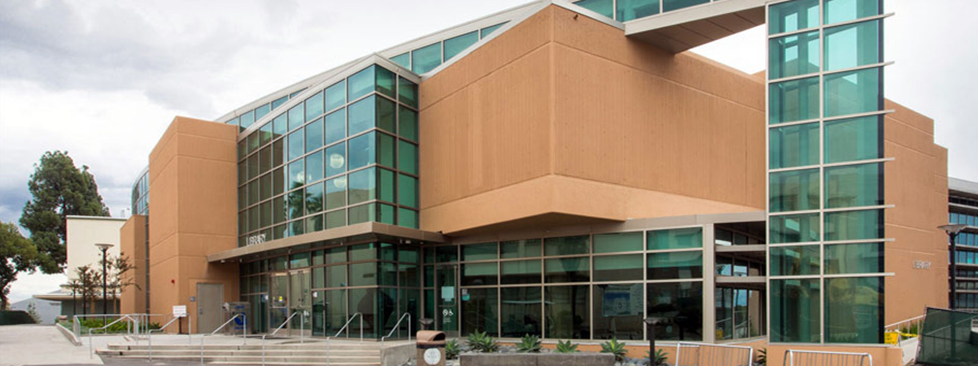

PMCS GROUP INC.
Contact: Violene Azar
Telephone: 562-498-0808
E-mail: vazar@pmcsgroup.net

PPM GROUP
Contact: Michael Tahan
Telephone: 909-262-4770
E-mail: mtahan@ppmgroup-inc.com

RAMOS CONSULTING SERVICES, INC.
Contact: Armando Ramos
Telephone: 626-905-4888
E-mail: aramos@ramoscs.com

RVA MANAGEMENT, INC.
Contact: Aman Vaish
Telephone: 626-710-2150
E-mail: amanv@rvamanagement.net

SAFNA ENGINEERING
Contact: Jorge Ramirez
Telephone: 626-599-8566
E-mail: jramirez@heateflex.com

SEC, LLC
Contact: Jay K. Tourgoutian
Telephone: 424-248-9910
E-mail: JTourgoutian@SECgroupco.com

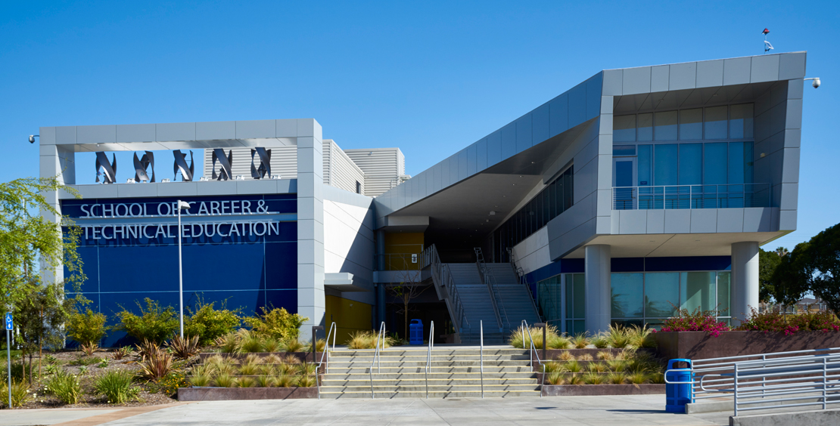

SWINERTON BUILDERS
Contact: Lia Tatevosian
Telephone: 213-896-3400
E-mail: Itatevosian@swinerton.com

TELACU CONSTRUCTION
Contact: Daniel Clem
Telephone: 714-541-2390-308
E-mail: dclem@telacu.com

THE “G” CREW
Contact: Ella Dava
Telephone: 818-240-4157
E-mail: ella@thegcrew.com

THE GREENRIDGE GROUP
Contact: James B. Allison
Telephone: 818-963-1396
E-mail: jallison@greenridge.bz

