**B**uilding for Tomorrow’s Leaders

**PRIME**

***CORDOBA CORPORATION***

Emily Ryan

(714)714-2212

[Eryan@cordobacorp.com](mailto:Eryan@cordobacorp.com)

**CONTACT**

## FACILITIES PLANNING & PROGRAM SERVICES, INC.

Contact: Ron Beeler

Telephone: 714-267-7209

E-mail: [ronbeeler@fpps.us](mailto:ronbeeler@fpps.us)

## GATEWAY SCIENCE & ENGINEERING

Contact: James Villanueva

Telephone: 626-696-1600

E-mail: jvillanueva@gateway-sci-eng.com

## JKH CONSULTING, LLC

Contact: Jamarah Hayner

Telephone: 646-262-8044

E-mail: jamarah@jkhconsultingservices.com

## M2P CONSULTING

Contact: David Ploog

Telephone: 212-203-9655

E-mail: ploog@m2p.net

## MASSETTI CONSULTING

Contact: Steve Massetti

Telephone: 310-923-3216

E-mail: [Steve@massetticonsulting.com](mailto:Steve@massetticonsulting.com)

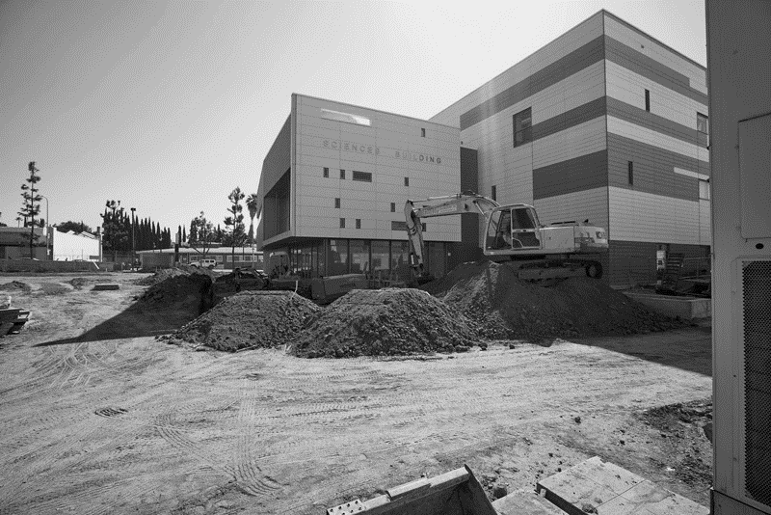

## PMA CONSULTANTS LLC

Contact: Dina Keirouz

Telephone: 562-637-7966

E-mail: [dkeirouz@pmaconsultants.com](mailto:dkeirouz@pmaconsultants.com)

## PAUL HANSEN ENGINEERING

Contact: Paul Hansen

Telephone: 310-935-8586

Email: [paul.hansen@paulhansenengineering.com](mailto:paul.hansen@paulhansenengineering.com)

## SMB MANAGEMENT SERVICES

Contact: Sheere Bishop-Griego

Telephone: 310-218-2507

E-mail: [sheere@smb](mailto:Steve@massetticonsulting.com)mgmtsvcs.com