ANd9GcRH-nPeIgT5zH9KhvQbXc63CPkj9IXipbW8mI5WZSi_d7UcFIvUNw

**College Internship Program**

* Be enrolled at one of the Los Angeles Community College District (LACCD) campuses; recent graduate or transfer student
* Go to [www.build-laccd.org](http://www.build-laccd.org) and click on CED tab, click on college internship app.
* Complete an internship application
* Complete a written statement of interest attached to application
* Provide copy of student ID from the community college you are attending *or*
* Copy of registration form for any specialty or noncredit program you are enrolled with at the college
* Provide a current resume
* Submit completed application and all requested documents to:

***mareta.zuniga@Build-LACCD.org***

**How Do I Apply?**



Enter Contact Information Here | 1127 Lombard Blvd. San Francisco, CA 59802 | phone 555.555.5555 | fax 555.555.5555

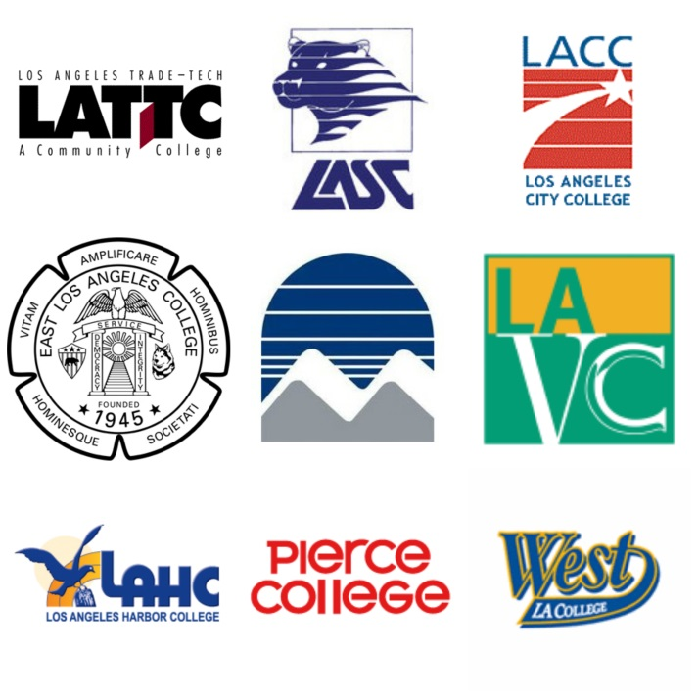

**CONTACT INFORMATION:**

**Mareta Zúñiga  
College Internship Coordinator**

**Phone | 323-981-7224**

**Email | mareta.zuniga@build-laccd.org**

INTERNSHIP OPPORTUNITIES IN:

* Construction Management
* Architecture/Design
* Engineering
* Technology
* Finance/Accounting
* Business/communication and more….

The Build-LACCD Internship Program is designed for LACCD college students looking to explore career options while building the skills and experience necessary to pave a pathway to careers in Science, Technology, Engineering and Mathematics (STEM) and other related opportunities within the construction industry.

**Internship PROGRAM BENEFITS:**

* Gain valuable work experience and transferable skills
* Earn while you learn
* Be able to experience a prospective career path
* Network with professionals in your field, for references and future job opportunities
* Flexible hours to accommodate your schedule

**“*Creating PATHWAYS FOR CARREER ADVANCEMENT”***

**JOIN BUILD-LACCD’s COLLEGE INTERNSHIP PROGRAM**

**FAQ’s**

***Are the internships paid?***

Yes, all internships are paid opportunities. There are also opportunities for students to volunteer.

***How much time will the internship require?***

Most internship opportunities are available for full-time or part-time internships. This will depend on the need of the employer.

***How will I be notified if I am selected for an interview?***

If selected, you will be notified by phone or email. We need to have your most up to date contact information as well as information of your availability.

pathways by collaborating with on-site businesses and firms.

The Build-LACCD Program is committed to supporting educational and vocational opportunities at the nine LACCD colleges. If interested, contact Mareta Zúñiga, Internship Coordinator via email or telephone. For further information regarding the Internship Program, see the FAQ’s below:

Build-LACCD’s Internship Program is designed to expand opportunities on Los Angeles Community College District (LACCD) Bond Construction Projects, providing students with internship opportunities with firms and contractors performing work on the Build Program.

The internships are available in a variety of occupations in the Science, Technology, Engineering and Mathematics (STEM) field including but not limited to construction management, architecture, engineering, and design and information technology (IT), accounting, business administration. The Internship Program will provide students with the skills necessary to succeed in a STEM-related career or their related

# **PROGRAM GOALS**

* Access to meaningful internship opportunities for local students
* Develop work readiness to increase student success in professional work environment
* Provide an opportunity to contribute to the design, construction and operations of campus facilities
* Create long-term mentorship opportunities for students

ANd9GcRH-nPeIgT5zH9KhvQbXc63CPkj9IXipbW8mI5WZSi_d7UcFIvUNw **College Internship Program**